ModelWriter

WP1 - Industrial Use Cases and Requirements (AIRBUS) 3

T1.1 - Evaluation Methods & Tools [UNIT + KOCSISTEM + AIRBUS + OBEO + HISBIM + MANTIS + SOGETI] 3

T1.2 - Industrial Use Cases for Belgium Consortium [SA -> SOGETI] 3

T1.3 - Industrial Use Cases for French Consortium [AIRBUS + OBEO] 4

T1.4 - Industrial Use Cases for Turkish Consortium [MANTIS + UNIT + KOCSISTEM + HISBIM] 4

T1.5 - Consolidated User Requirements [SA -> AIRBUS + OBEO + MANTIS + SOGETI] 4

T1.6 - User Requirements Review [SA -> AIRBUS + UNIT + KOCSISTEM + KUL + ALL] 4

T1.7 - Software Requirements [SA -> AIRBUS + LORIA + UNIT + MANTIS + OBEO + SOGETI] 5

T1.8 - Software Requirements Review [SA -> AIRBUS + UNIT + KOCSISTEM + ALL] 5

T1.9 - Annual Product Review [SA -> AIRBUS + Country Coordinators - "Product Review Committee"] 5

T1.10 - Technical Risk Assessment and Management [OBEO + UNIT + KOCSISTEM + ALL] 5

WP2 - Semantic Parsing and Generation of Documents and Documents Components (LORIA) 6

T2.1 - Data Collection [LORIA + KUL -SA + OBEO + AIRBUS +SOGETI] 6

T2.2 - Hybrid approaches to semantic parsing [KUL1 + LORIA] 6

T2.3 - Hybrid approaches to Natural Language Generation [LORIA + KUL2 + KUL1] 7

T2.4 - Definition of the target semantic representation language [+ KUL2 + KUL1 + LORIA + OBEO + AIRBUS] 7

T2.5 - Development of the semantic parser and of the generator [LORIA + KUL1 + MANTIS - KUL2 + AIRBUS + OBEO] 7

WP3 - Model to/from Knowledge Base (UNIT) 9

T3.1 - Review of M2M transformation approaches [UNIT + KOCSISTEM] 9

T3.2 - Specification and design of the M2M Transformation Framework [UNIT + KOCSISTEM] 9

T3.3 - Development of the Transformation Manager component [UNIT + KOCSISTEM] 9

T3.4 - Development of the Configuration Manager (COM) component [UNIT + KOCSISTEM] 10

T3.5 - Development of the Traceability Manager component [UNIT + KOCSISTEM] 10

T3.6 - Development of the Synchronization Manager component [UNIT + KOCSISTEM] 11

T3.7 - Design of the model-to-model transformations [UNIT + MANTIS + KUL2] 11

T3.8 - Implementation of the model-to-model transformations [UNIT + KUL2] 11

T3.9 - Validation of the M2M Transformation Framework [UNIT + MANTIS + KUL2 + KOCSISTEM] 11

WP4 - Knowledge Base Design and Implementation (Mantis) 13

T4.1 - Design of the Knowledge Base [KUL2 - SA + OBEO + MANTIS + UNIT + KOCSISTEM] 13

T4.2 - API of the Knowledge Base [KUL2 + KOCSISTEM + OBEO + UNIT + HISBIM] 13

T4.3 - Implementation of the Knowledge Base [KUL2 + MANTIS + HISBIM] 13

T4.4 - Plug-in #1: ModelWriter-assisted requirements review [- KUL2 - SA] 14

T4.5 - Knowledge Base serialization and reuse plug-in [MANTIS] 14

T4.6 - Plug-in #3: ModelWriter-assisted semantic comparison of 2 documents [OBEO + MANTIS + HISBIM] 14

T4.7 - Plug-in #2: ModelWriter-assisted compliance review [-SA + MANTIS + UNIT + AIRBUS +SOGETI] 15

T4.9 - Internal bi-directional synchronization mechanism [OBEO + UNIT] 15

T4.10 - External synchronization mechanism for collaborating ModelWriters [SA -> HISBIM] 15

WP5 - Project Management (UNIT) 16

T5.1 - Communication Management and Collaboration Infrastructure [SA -> UNIT + WP7 leader] 16

T5.2 - Project Coordination and Reporting [SA -> UNIT + Country Coordinators + WP Leaders] 16

T5.3 - Closing Project [SA -> UNIT + WP Leaders] 17

WP6 - ModelWriter Architecture, Integration and Evaluation (OBEO) 18

T6.1 - Experimental Prototyping [OBEO + UNIT] 18

T6.2 - Architectural Design [OBEO + UNIT + MANTIS + technological WP Leaders] 18

T6.3 - Writer Part enhancements [UNIT + KOCSISTEM + SOGETI] 18

T6.4 - User Interfaces Implementation [OBEO + SOGETI + UNIT + KOCSISTEM] 19

T6.5 - Acceptance Test Plan [UNIT + KOCSISTEM + ALL] 19

T6.6 - Acceptance Test Procedures [SOGETI + UNIT + KS + ALL] 20

T6.7 - ModelWriter Integration [OBEO + UNIT + ALL] 20

T6.8 - Cyclic Evaluation of Analysis Performance [SOGETI + OBEO + LORIA + UNIT + KOCSISTEM + ALL] 21

WP7 - Dissemination and Exploitation (OBEO) 22

T7.1 - Dissemination Plan [OBEO + UNIT + LORIA + KS + ALL] 22

T7.2 - Business Model & Exploitation Plan [AIRBUS + SOGETI + OBEO + all industrial partners] 22

T7.3 - Workshops & Events [+ KUL2 + UNIT + OBEO + KS + AIRBUS + ALL] 23

T7.4 - ModelWriter-ITEA Consortium Website [OBEO + UNIT] 23

T7.5 - Community Forum & Open Source Campaign [OBEO + UNIT] 23

T7.6 - Social Networks [UNIT + KOCSISTEM] 23

T7.7 - Standardization [LORIA + UNIT + KOCSISTEM] 24

## WP1 - Industrial Use Cases and Requirements (AIRBUS)

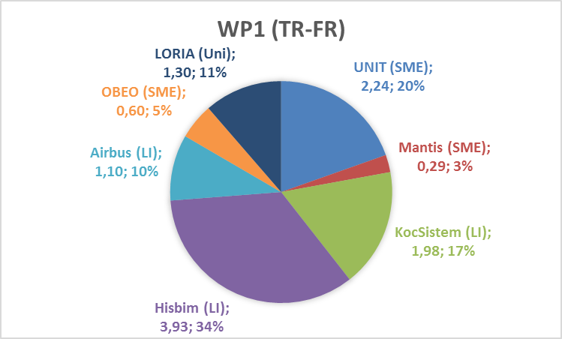 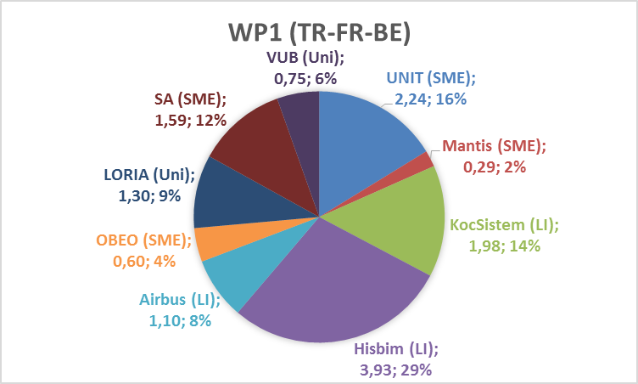

### T1.1 - Evaluation Methods & Tools [UNIT + KOCSISTEM + AIRBUS + OBEO + HISBIM + MANTIS + SOGETI]

| **Month** | **Deliverable** | **Type** | **Access** | **Leader** |
| --- | --- | --- | --- | --- |
| [M3 -> M5] | D1.1.1 Report: Evaluation Methods & Tools | Doc. | Public | UNIT -> HISBIM |

### T1.2 - Industrial Use Cases for Belgium Consortium [SA -> SOGETI]

| **Month** | **Deliverable** | **Type** | **Access** | **Leader** |
| --- | --- | --- | --- | --- |
| [M3 -> M7] | D1.2.1 Report: Industrial Use Cases for Belgian Consortium | Doc. | Public | SOGETI |
| [M3 -> M7] | D1.2.2 Data: Corpus for D1.2.1 (public part) | SW | Public | SOGETI |
| [M3 -> M7] | D1.2.3 Data: Corpus for D1.2.1 (confidential part) | SW | Confidential | SOGETI |

### T1.3 - Industrial Use Cases for French Consortium [AIRBUS + OBEO + LORIA]

| **Month** | **Deliverable** | **Type** | **Access** | **Leader** |
| --- | --- | --- | --- | --- |
| [M3 -> M5] | D1.3.1 Report: Industrial Use Cases for French Consortium | Doc. | Public | AIRBUS |
| [M3 -> M5] | D1.3.2 Data: Corpus for D1.2.1 (public part) | SW | Public | AIRBUS |
| [M3 -> M5] | D1.3.3 Data: Corpus for D1.2.1 (confidential part) | SW | Confidential | AIRBUS |

### T1.4 - Industrial Use Cases for Turkish Consortium [MANTIS + UNIT + KOCSISTEM + HISBIM]

| **Month** | **Deliverable** | **Type** | **Access** | **Leader** |
| --- | --- | --- | --- | --- |
| [M3 -> M7] | D1.4.1 Report: Industrial Use Cases for Turkish Consortium | Doc. | Public | MANTIS |
| [M3 -> M7] | D1.4.2 Data: Corpus for D1.3.1 (public part) | SW | Public | MANTIS |
| [M3 -> M7] | D1.4.3 Data: Corpus for D1.3.1 (confidential part) | SW | Confidential | MANTIS |

### T1.5 - Consolidated User Requirements [SA -> AIRBUS + OBEO + MANTIS + SOGETI]

| **Month** | **Deliverable** | **Type** | **Access** | **Leader** |
| --- | --- | --- | --- | --- |
| [M3 -> M7] | D1.5.1 Report: User Requirements Document (URD) for ModelWriter | Doc. | Public | SA -> UNIT |

### T1.6 - User Requirements Review [SA -> AIRBUS + UNIT + KOCSISTEM + KUL + ALL]

| **Month** | **Deliverable** | **Type** | **Access** | **Leader** |
| --- | --- | --- | --- | --- |
| [M3 -> M7] | D1.6.1 Report: Minutes of the User Requirements Review meeting | Doc. | Public | SA -> HISBIM |

### T1.7 - Software Requirements [SA -> AIRBUS + LORIA + UNIT + MANTIS + OBEO + SOGETI]

| **Month** | **Deliverable** | **Type** | **Access** | **Leader** |
| --- | --- | --- | --- | --- |
| [M5 -> M9] | D1.7.1 Report: Software Requirements Document (SRD) for ModelWriter | Doc. | Public | SA -> KOCSISTEM |

### T1.8 - Software Requirements Review [SA -> AIRBUS + UNIT + KOCSISTEM + ALL]

| Month | Deliverable | Type | Access | Leader |
| --- | --- | --- | --- | --- |
| [M5 -> M9] | D1.8.1 Report: Minutes of the Software Requirements Review meeting | Doc. | Public | SA -> AIRBUS |

### T1.9 - Annual Product Review [SA -> AIRBUS + Country Coordinators - "Product Review Committee"]

| Month | Deliverable | Type | Access | Leader |
| --- | --- | --- | --- | --- |
| [M13 -> M15] | D1.9.1-1 Report: Annual Product Owner Review | Doc. | Public | SA -> AIRBUS |
| [M25 -> M26] | D1.9.1-2 Report: Annual Product Owner Review | Doc. | Public | SA -> AIRBUS |
| [M37] | D1.9.1-3 Report: Annual Product Owner Review | Doc. | Public | SA -> AIRBUS |

### T1.10 - Technical Risk Assessment and Management [OBEO + UNIT + KOCSISTEM + ALL]

| Month | Deliverable | Type | Access | Leader |
| --- | --- | --- | --- | --- |
| [M5 -> M9] | D1.10.1 Technical Risk Assessment Document | Doc. | Public | OBEO |

## WP2 - Semantic Parsing and Generation of Documents and Documents Components (LORIA)

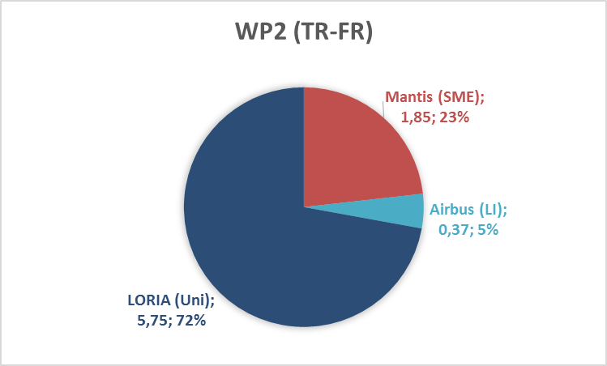 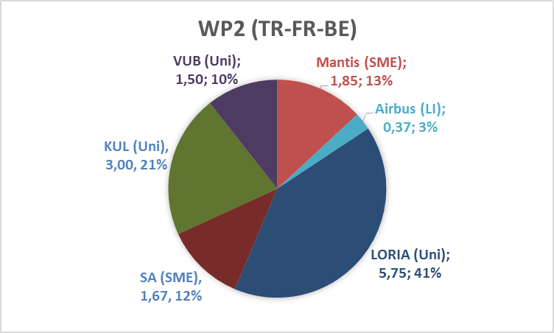

### T2.1 - Data Collection [LORIA + KUL -SA + OBEO + AIRBUS +SOGETI]

| **Month** | **Deliverable** | **Type** | **Access** | **Leader (Members)** |
| --- | --- | --- | --- | --- |
| [M3 -> M7 -> M8] | D2.1.1 Report: Software Requirements - Evaluation of the natural language processing requirements set by the use cases | Doc. | Public | LORIA (KUL1) |
| [M6 -> M8] | D2.1.2 Data: Corpora (Text, Knowledge, Bi-Texts) and Report: Documentation of the corpora | Doc. | Public | LORIA (OBEO, AIRBUS, KUL1) |

### T2.2 - Hybrid approaches to semantic parsing [KUL1 + LORIA]

| **Month** | **Deliverable** | **Type** | **Access** | **Leader (Members)** |
| --- | --- | --- | --- | --- |
| [M4 -> M12] | D2.2.1 Report: Overview and comparison of existing deep semantic parsers | Doc. | Public | KUL1 -> LORIA (KUL1) [KUL1] |

### T2.3 - Hybrid approaches to Natural Language Generation [LORIA + KUL2 + KUL1]

| **Month** | **Deliverable** | **Type** | **Access** | **Leader (Members)** |
| --- | --- | --- | --- | --- |
| [M5 -> M7] | D2.3.1 Report: Overview and comparison of existing generators | Doc. | Public | LORIA (KUL1) |

### T2.4 - Definition of the target semantic representation language [+ KUL2 + KUL1 + LORIA + OBEO + AIRBUS]

| **Month** | **Deliverable** | **Type** | **Access** | **Leader** |
| --- | --- | --- | --- | --- |
| [M8 -> M10] | D2.4.1 Report: Specification of the Knowledge Representation Language(s) output by the parser and input to the generator | Doc. | Public | KUL2 -> LORIA (OBEO, AIRBUS) [KUL2] |

### T2.5 - Development of the semantic parser and of the generator [LORIA + KUL1 + MANTIS - KUL2 + AIRBUS + OBEO]

| **Month** | **Deliverable** | **Type** | **Access** | **Leader (Members)** |
| --- | --- | --- | --- | --- |
| [M8 -> M17] | D2.5.1-1 Software: Semantic Parser and Report: Software Documentation (release 1) | SW | Public | KUL1 -> LORIA (KUL1, MANTIS) [KUL2] |
| [M20 -> M25] | D2.5.1-2 Software: Semantic Parser and Report: Software Documentation (release 2) | SW | Public | KUL1 -> LORIA (KUL1, MANTIS) [KUL2] |
| [M28 -> M30] | D2.5.1-3 Software: Semantic Parser and Report: Software Documentation (release 3) | SW | Public | KUL1 -> LORIA (KUL1, MANTIS) [KUL2] |

| **Month** | **Deliverable** | **Type** | **Access** | **Leader (Members)** |
| --- | --- | --- | --- | --- |
| [M8 -> M10] | D2.5.2-1 Software: Natural Language Generator and Report: Software Documentation (release 1) | SW | Public | LORIA (KUL1, MANTIS) |
| [M20 -> M22] | D2.5.2-2 Software: Natural Language Generator and Report: Software Documentation (release 2) | SW | Public | LORIA (KUL1, MANTIS) |
| [M28 -> M30] | D2.5.2-3 Software: Natural Language Generator and Report: Software Documentation (release 3) | SW | Public | LORIA (KUL1, MANTIS) |

## WP3 - Model to/from Knowledge Base (UNIT)

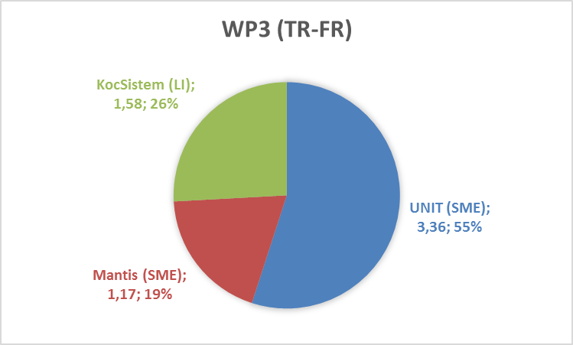 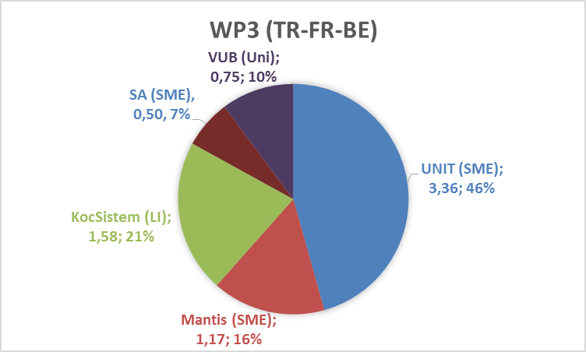

### T3.1 - Review of M2M transformation approaches [UNIT + KOCSISTEM]

| **Month** | **Deliverable** | **Type** | **Access** | **Leader** |
| --- | --- | --- | --- | --- |
| [M3 -> M5] | D3.1.1 Review of model-to-model transformation approaches and technologies | Doc. | Public | UNIT |

### T3.2 - Specification and design of the M2M Transformation Framework [UNIT + KOCSISTEM]

| **Month** | **Deliverable** | **Type** | **Access** | **Leader** |
| --- | --- | --- | --- | --- |
| [M4 -> M6] | D3.2.1 M2M Transformation Framework architectural design document | Doc. | Public | UNIT |

### T3.3 - Development of the Transformation Manager component [UNIT + KOCSISTEM]

| **Month** | **Deliverable** | **Type** | **Access** | **Leader** |
| --- | --- | --- | --- | --- |
| [M5 -> M7] | D3.3.1 Transformation Manager architectural (TRAM) design document | Doc. | Public | UNIT |
| [M8 -> M10] | D3.3.2-1 Software: Transformation Manager component (release 1) | SW | Public | UNIT |
| [M20 -> M22] | D3.3.2-2 Software: Transformation Manager component (release 2) | SW | Public | UNIT |
| [M30 -> M32] | D3.3.2-3 Software: Transformation Manager component (release 3) | SW | Public | UNIT |

### T3.4 - Development of the Configuration Manager (COM) component [UNIT + KOCSISTEM]

| **Month** | **Deliverable** | **Type** | **Access** | **Leader** |
| --- | --- | --- | --- | --- |
| [M6 -> M8] | D3.4.1 Configuration Manager architectural design document | Doc. | Public | UNIT |
| [M8 -> M10] | D3.4.2-1 Software: Configuration Manager component (release 1) | SW | Public | UNIT |
| [M20 -> M22] | D3.4.2-2 Software: Configuration Manager component (release 2) | SW | Public | UNIT |
| [M30 -> M32] | D3.4.2-3 Software: Configuration Manager component (release 3) | SW | Public | UNIT |

### T3.5 - Development of the Traceability Manager component [UNIT + KOCSISTEM]

| **Month** | **Deliverable** | **Type** | **Access** | **Leader** |
| --- | --- | --- | --- | --- |
| [M7 -> M9] | D3.5.1 Traceability Manager architectural design document | Doc. | Public | UNIT |
| [M8 -> M10] | D3.5.2-1 Software: Traceability Manager component (release 1) | SW | Public | UNIT |
| [M20 -> M22] | D3.5.2-2 Software: Traceability Manager component (release 2) | SW | Public | UNIT |
| [M30 -> M32] | D3.5.2-3 Software: Traceability Manager component (release 3) | SW | Public | UNIT |

### T3.6 - Development of the Synchronization Manager component [UNIT + KOCSISTEM]

| **Month** | **Deliverable** | **Type** | **Access** | **Leader** |
| --- | --- | --- | --- | --- |
| [M8 -> M10] | D3.6.1 Synchronization Manager architectural design document | Doc. | Public | UNIT |
| [M8 -> M10] | D3.6.2-1 Software: Synchronization Manager component (release 1) | SW | Public | UNIT |
| [M20 -> M22] | D3.6.2-2 Software: Synchronization Manager component (release 2) | SW | Public | UNIT |
| [M30 -> M32] | D3.6.2-3 Software: Synchronization Manager component (release 3) | SW | Public | UNIT |

### T3.7 - Design of the model-to-model transformations [UNIT + MANTIS + KUL2]

| **Month** | **Deliverable** | **Type** | **Access** | **Leader** |
| --- | --- | --- | --- | --- |
| [M18 -> M20] | D3.7.1 Model-to-model transformations (from user-visible models to KB-stored models) design document | Doc. | Public | UNIT -> MANTIS |

### T3.8 - Implementation of the model-to-model transformations [UNIT + KUL2]

| **Month** | **Deliverable** | **Type** | **Access** | **Leader** |
| --- | --- | --- | --- | --- |
| [M11 -> M13] | D3.8.1-1 Software: Source and binary code of each model-to-model transformation (release 1) | SW | Public | UNIT |
| [M21 -> M23] | D3.8.1-3 Software: Source and binary code of each model-to-model transformation (release 2) | SW | Public | UNIT [KUL2] |
| [M31 -> M33] | D3.8.1-3 Software: Source and binary code of each model-to-model transformation (release 3) | SW | Public | UNIT [KUL2] |

### T3.9 - Validation of the M2M Transformation Framework [UNIT + MANTIS + KUL2 + KOCSISTEM]

| **Month** | **Deliverable** | **Type** | **Access** | **Leader** |
| --- | --- | --- | --- | --- |
| [M32 -> M34] | D3.9.1 Test-plan for the M2M Transformation Framework | Doc. | Public | UNIT -> MANTIS |
| [M33 -> M35] | D3.9.2 Field experiment concerning ModelWriter model transformations | SW | Public | UNIT [KUL2] |

## WP4 - Knowledge Base Design and Implementation (Mantis)

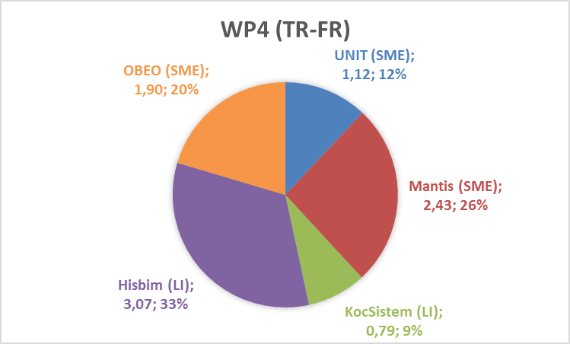 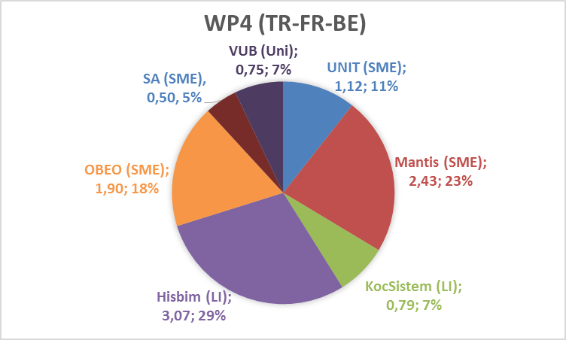

### T4.1 - Design of the Knowledge Base [KUL2 - SA + OBEO + MANTIS + UNIT + KOCSISTEM]

| **Month** | **Deliverable** | **Type** | **Access** | **Leader** |
| --- | --- | --- | --- | --- |
| [M6] -> [M7] | D4.1.1 Report: Knowledge Base Design document | Doc. | Public | KUL2 -> MANTIS |

### T4.2 - API of the Knowledge Base [KUL2 + KOCSISTEM + OBEO + UNIT + HISBIM]

| **Month** | **Deliverable** | **Type** | **Access** | **Leader** |
| --- | --- | --- | --- | --- |
| [M6] -> [M7] | D4.2.1 Report: Interface Control Document (ICD) | Doc. | Public | KUL2 -> KOCSISTEM |

### T4.3 - Implementation of the Knowledge Base [KUL2 + MANTIS + HISBIM]

| **Month** | **Deliverable** | **Type** | **Access** | **Leader** |
| --- | --- | --- | --- | --- |
| [M11 -> M13] | D4.3.1-1 Software: Knowledge Base (release 1) | SW | Public | KUL2 -> MANTIS |
| [M19 -> M23] | D4.3.1-2 Software: Knowledge Base (release 2) | SW | Public | KUL2 -> MANTIS |
| [M31 -> M33] | D4.3.1-3 Software: Knowledge Base (release 3) | SW | Public | KUL2 -> MANTIS |

### T4.4 - Plug-in #1: ModelWriter-assisted requirements review [- KUL2 - SA]

This plug-in and associated deliverables were suggested by KUL2.

| **Month** | **Deliverable** | **Type** | **Access** | **Leader** |
| --- | --- | --- | --- | --- |
| [M35] | D4.4.1 Report: Technical Note for ModelWriter-assisted Quality Review of Requirements | Doc. | Public | KUL2 -> MANTIS [KUL2] |
| [M35] | D4.4.2 Software: Proof-of-concept model checker | SW | Public | KUL2 -> MANTIS [KUL2] |

### T4.5 - Knowledge Base serialization and reuse plug-in [MANTIS]

| **Month** | **Deliverable** | **Type** | **Access** | **Leader** |
| --- | --- | --- | --- | --- |
| [M11 -> M13] | D4.5.1 Report: Technical Note for KB serialization and reuse | Doc. | Public | MANTIS |

### T4.6 - Plug-in #3: ModelWriter-assisted semantic comparison of 2 documents [OBEO + MANTIS + HISBIM]

| **Month** | **Deliverable** | **Type** | **Access** | **Leader** |
| --- | --- | --- | --- | --- |
| [M20] | D4.6.1 Report: Technical Note for ModelWriter-assisted Comparison of 2 Documents | Doc. | Public | OBEO |
| [M11] -> M13] | D4.6.2-1 Software: Proof-of-concept semantic comparison engine (release 1) | SW | Public | OBEO |
| [M19] -> M23] | D4.6.2-2 Software: Proof-of-concept semantic comparison engine (release 2) | SW | Public | OBEO |
| [M31] -> M33] | D4.6.2-3 Software: Proof-of-concept semantic comparison engine (release 3) | SW | Public | OBEO |

### T4.7 - Plug-in #2: ModelWriter-assisted compliance review [-SA + MANTIS + UNIT + AIRBUS +SOGETI]

| **Month** | **Deliverable** | **Type** | **Access** | **Leader** |
| --- | --- | --- | --- | --- |
| [M10] -> [M14] | D4.7.1 Report: Future ModelWriter-Enabled Use Cases | Doc. | Public | SA -> MANTIS [SOGETI] |

### T4.9 - Internal bi-directional synchronization mechanism [OBEO + UNIT]

### T4.10 - External synchronization mechanism for collaborating ModelWriters [SA -> HISBIM]

## WP5 - Project Management (UNIT)

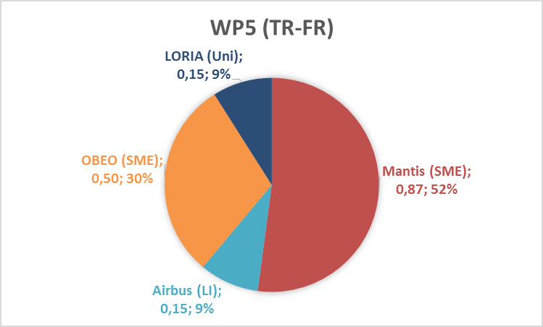 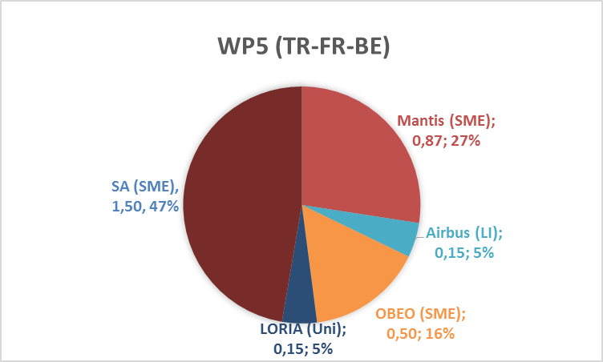

### T5.1 - Communication Management and Collaboration Infrastructure [SA -> UNIT + WP7 leader]

| **Month** | **Deliverable** | **Type** | **Access** | **Leader** |
| --- | --- | --- | --- | --- |
| [M1] | D5.1.1 Project Kick-Off Report and Project Management Plan | Doc. | Public | UNIT |

### T5.2 - Project Coordination and Reporting [SA -> UNIT + Country Coordinators + WP Leaders]

| **Month** | **Deliverable** | **Type** | **Access** | **Leader** |
| --- | --- | --- | --- | --- |
| [M7] | D5.2.1 Project Progress Report (first half year) | Doc. | Confidential | UNIT |
| [M13] | D5.2.2 Project Progress Report (second half year) | Doc. | Confidential | UNIT |
| [M19] | D5.2.3 Project Progress Report (third half year) | Doc. | Confidential | UNIT |
| [M25] | D5.2.4 Project Progress Report (fourth half year) | Doc. | Confidential | UNIT |
| [M31] | D5.2.5 Project Progress Report (fifth half year) | Doc. | Confidential | UNIT |

### T5.3 - Closing Project [SA -> UNIT + WP Leaders]

| **Month** | **Deliverable** | **Type** | **Access** | **Leader** |
| --- | --- | --- | --- | --- |
| [M37] | D5.3.1 Final Project Report | Doc. | Confidential | UNIT |
| [M37] | D5.3.2 Updated State-of-the-art (Public Deliverable) | Doc. | Public | UNIT |

## WP6 - ModelWriter Architecture, Integration and Evaluation (OBEO)

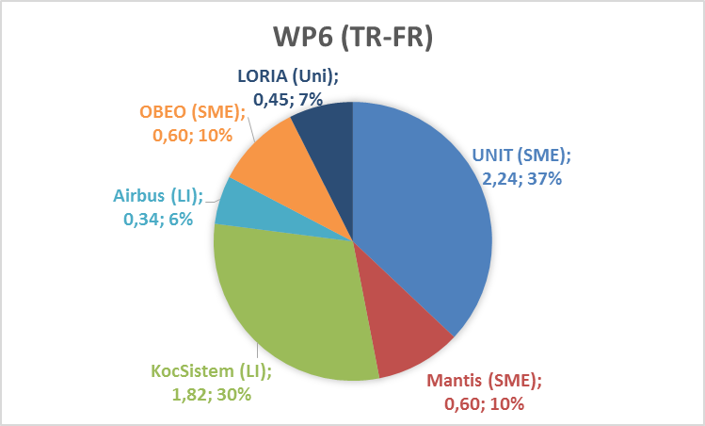 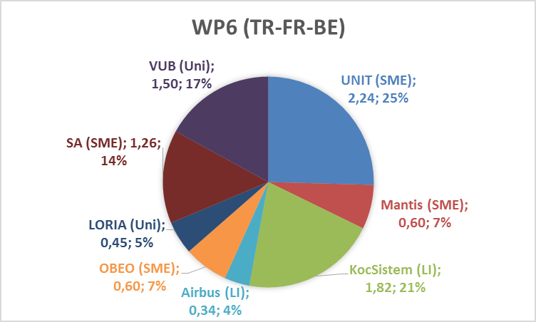

### T6.1 - Experimental Prototyping [OBEO + UNIT]

| **Month** | **Deliverable** | **Type** | **Access** | **Leader** |
| --- | --- | --- | --- | --- |
| [M5 -> M6] | D6.1.1 Software: Prototype Core ModelWriter | SW | Public | OBEO |

### T6.2 - Architectural Design [OBEO + UNIT + MANTIS + technological WP Leaders]

| **Month** | **Deliverable** | **Type** | **Access** | **Leader** |
| --- | --- | --- | --- | --- |
| [M5 -> M6] | D6.2.1 Report: Architectural Design Document (ADD) (OBEO, Mantis) | Doc. | Public | OBEO |

### T6.3 - Writer Part enhancements [UNIT + KOCSISTEM + SOGETI]

| **Month** | **Deliverable** | **Type** | **Access** | **Leader** |
| --- | --- | --- | --- | --- |
| [M10] | D6.3.1-1 Software: Writer enhancements (release 1) | SW | Public | SA -> KOCSISTEM [SOGETI] |
| [M20] | D6.3.1-2 Software: Writer enhancements (release 2) | SW | Public | SA -> KOCSISTEM [SOGETI] |
| [M34] | D6.3.1-3 Software: Writer enhancements (release 3) | SW | Public | SA -> KOCSISTEM [SOGETI] |

### T6.4 - User Interfaces Implementation [OBEO + SOGETI + UNIT + KOCSISTEM]

User Interface for the Writer part [- SA]

| **Month** | **Deliverable** | **Type** | **Access** | **Leader** |
| --- | --- | --- | --- | --- |
| [M7] -> [M9] | D6.4.1 Report: Ergonomics Guidelines document for the Writer Part | Doc. | Public | SA -> OBEO |
| [M10] -> [M12] | D6.4.2-1 Software: User Interface for the Writer part (release 1) | SW | Public | SA -> OBEO [SOGETI] |
| [M20] | D6.4.2-2 Software: User Interface for the Writer part (release 2) | SW | Public | SA -> OBEO [SOGETI] |
| [M34] | D6.4.2-3 Software: User Interface for the Writer part (release 3) | SW | Public | SA -> OBEO [SOGETI] |

Software: IDE-integrated User Interface to handle Synchronization [Obeo]

| **Month** | **Deliverable** | **Type** | **Access** | **Leader** |
| --- | --- | --- | --- | --- |
| [M10] -> [M12] | D6.4.3-1 Software: IDE-integrated User Interface to handle Synchronization issues major release (release 1) | SW | Public | OBEO |
| [M20] | D6.4.3-2 Software: IDE-integrated User Interface to handle Synchronization issues major release (release 2) | SW | Public | OBEO |
| [M34] | D6.4.3-3 Software: IDE-integrated User Interface to handle Synchronization issues major release (release 3) | SW | Public | OBEO |

### T6.5 - Acceptance Test Plan [UNIT + KOCSISTEM + ALL]

| **Month** | **Deliverable** | **Type** | **Access** | **Leader** |
| --- | --- | --- | --- | --- |
| [M10] -> [M12] | D6.5.1-1 Report: Acceptance Test Plan (release 1) (SA + all) | Doc. | Public | SA -> KOCSISTEM [SOGETI] |
| [M20] | D6.5.1-2 Report: Acceptance Test Plan (release 2) (SA + all) | Doc. | Public | SA -> KOCSISTEM [SOGETI] |
| [M34] | D6.5.1-3 Report: Acceptance Test Plan (release 3) (SA + all) | Doc. | Public | SA -> KOCSISTEM [SOGETI] |
| [M10] -> [M12] | D6.5.2-1 Software: Automated Acceptance Tests (release 1) (SA + all | SW | Public | SA -> KOCSISTEM [SOGETI] |
| [M20] | D6.5.2-2 Software: Automated Acceptance Tests (release 2) (SA + all) | SW | Public | SA -> KOCSISTEM [SOGETI] |
| [M34] | D6.5.2-3 Software: Automated Acceptance Tests (release 3) (SA + all) | SW | Public | SA -> KOCSISTEM [SOGETI] |

### T6.6 - Acceptance Test Procedures [SOGETI + UNIT + KS + ALL]

| **Month** | **Deliverable** | **Type** | **Access** | **Leader** |
| --- | --- | --- | --- | --- |
| [M10] -> [M12] | D6.6.1-1 Report: Acceptance Test Procedures (release 1) (SA + all) | Doc. | Public | SA -> KOCSISTEM [SOGETI] |
| [M20] | D6.6.1-2 Report: Acceptance Test Procedures (release 2) (SA + all) | Doc. | Public | SA -> KOCSISTEM [SOGETI] |
| [M34] | D6.6.1-3 Report: Acceptance Test Procedures (release 3) (SA + all) | Doc. | Public | SA -> KOCSISTEM [SOGETI] |

### T6.7 - ModelWriter Integration [OBEO + UNIT + ALL]

| **Month** | **Deliverable** | **Type** | **Access** | **Leader** |
| --- | --- | --- | --- | --- |
| [M11] -> [M13] | D6.7.1-1 Software: ModelWriter major release (release 1) | SW | Public | OBEO |
| [M23] | D6.7.1-2 Software: ModelWriter major release (release 2) | SW | Public | OBEO |
| [M35] | D6.7.1-3 Software: ModelWriter major release (release 3) | SW | Public | OBEO |

| **Month** | **Deliverable** | **Type** | **Access** | **Leader** |
| --- | --- | --- | --- | --- |
| [M10 -> M18] | D6.7.2-1 Software: WP2 Integration in ModelWriter and Report: Software Documentation (release 1) | SW | Public | SA -> OBEO |
| [M22 -> M26] | D6.7.2-2 Software: WP2 Integration in ModelWriter and Report: Software Documentation (release 2) | SW | Public | SA -> OBEO [SOGETI] |
| [M30 -> M31] | D6.7.2-3 Software: WP2 Integration in ModelWriter and Report: Software Documentation (release 3) | SW | Public | SA -> OBEO [SOGETI] |

### T6.8 - Cyclic Evaluation of Analysis Performance [SOGETI + OBEO + LORIA + UNIT + KOCSISTEM + ALL]

| **Month** | **Deliverable** | **Type** | **Access** | **Leader** |
| --- | --- | --- | --- | --- |
| [M12] -> [M14] | D6.8.1-1 Report: Evaluation report (release 1) (All) | Doc. | Public | SA -> KOCSISTEM [SOGETI] |
| [M24] | D6.8.1-2 Report: Evaluation report (release 2) (All) | Doc. | Public | SA -> KOCSISTEM [SOGETI] |
| [M36] | D6.8.1-3 Report: Evaluation report (release 3) (All) | Doc. | Public | SA -> KOCSISTEM [SOGETI] |

## WP7 - Dissemination and Exploitation (OBEO)

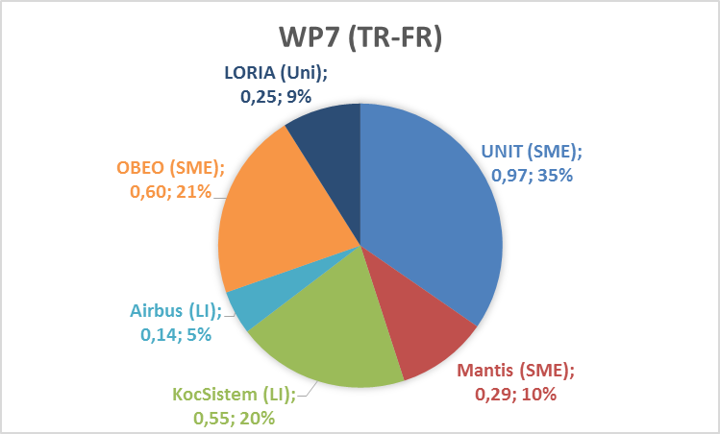 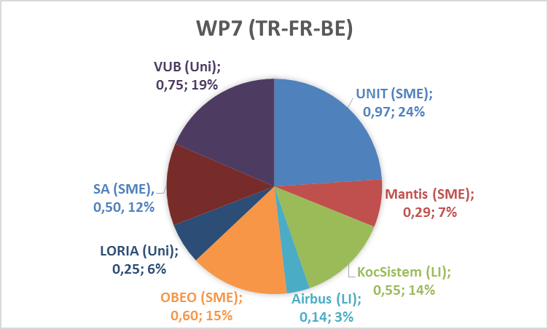

### T7.1 - Dissemination Plan [OBEO + UNIT + LORIA + KS + ALL]

| **Month** | **Deliverable** | **Type** | **Access** | **Leader** |
| --- | --- | --- | --- | --- |
| [M4 -> M6] | D7.1.1 Dissemination Plan | Doc. | Public | OBEO |

### T7.2 - Business Model & Exploitation Plan [AIRBUS + SOGETI + OBEO + all industrial partners]

| **Month** | **Deliverable** | **Type** | **Access** | **Leader** |
| --- | --- | --- | --- | --- |
| [M7] | D7.2.1-1 Exploitation Plan (release 1) | Doc. | Public | AIRBUS |
| [M22] | D7.2.1-2 Exploitation Plan (release 2) | Doc. | Public | AIRBUS |
| [M34] | D7.2.1-3 Exploitation Plan (release 3) | Doc. | Public | AIRBUS |
| [M7] – [M8] | D7.2.2 Marketing Plan | Doc. | Public | AIRBUS -> HISBIM |
| [M34] | D7.2.3 Road-map for future exploitation and pre-competition survey | Doc. | Public | AIRBUS -> HISBIM |

### T7.3 - Workshops & Events [+ KUL2 + UNIT + OBEO + KS + AIRBUS + ALL]

| **Month** | **Deliverable** | **Type** | **Access** | **Leader** |
| --- | --- | --- | --- | --- |
| [M31] | D7.3.1 Newsletter - International Conference Announcement | Doc. | Public | KUL2 -> UNIT |

### T7.4 - ModelWriter-ITEA Consortium Website [OBEO + UNIT]

| **Month** | **Deliverable** | **Type** | **Access** | **Leader** |
| --- | --- | --- | --- | --- |
| [M1 -> M8] | D7.4.1 ModelWriter-ITEA website including secured intranet | SW | Public | SA -> OBEO |

### T7.5 - Community Forum & Open Source Campaign [OBEO + UNIT]

| **Month** | **Deliverable** | **Type** | **Access** | **Leader** |
| --- | --- | --- | --- | --- |
| [M10] | D7.5.1 Technical-oriented talk about the principles and benefits of the ModelWriter-ITEA approach and tooling | Doc. | Public | KUL2 -> OBEO |
| [M10] | D7.5.2 Research-oriented talk about the principles and benefits of the ModelWriter-ITEA approach and tooling | Doc. | Public | KUL2 -> UNIT |

### T7.6 - Social Networks [UNIT + KOCSISTEM]

| **Month** | **Deliverable** | **Type** | **Access** | **Leader** |
| --- | --- | --- | --- | --- |
| [M10] | D7.6.1 ModelWriter-ITEA's LinkedIn Group | SW | Public | UNIT |
| [M10] | D7.6.2 ModelWriter-ITEA's Twitter Group | SW | Public | UNIT |

### T7.7 - Standardization [LORIA + UNIT + KOCSISTEM]

| **Month** | **Deliverable** | **Type** | **Access** | **Leader** |
| --- | --- | --- | --- | --- |
| [M34] | D7.7.1 ModelWriter and standardization activities | SW | Public | LORIA |